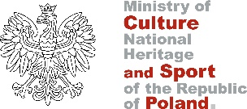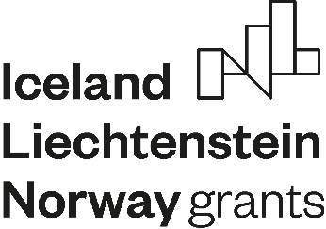

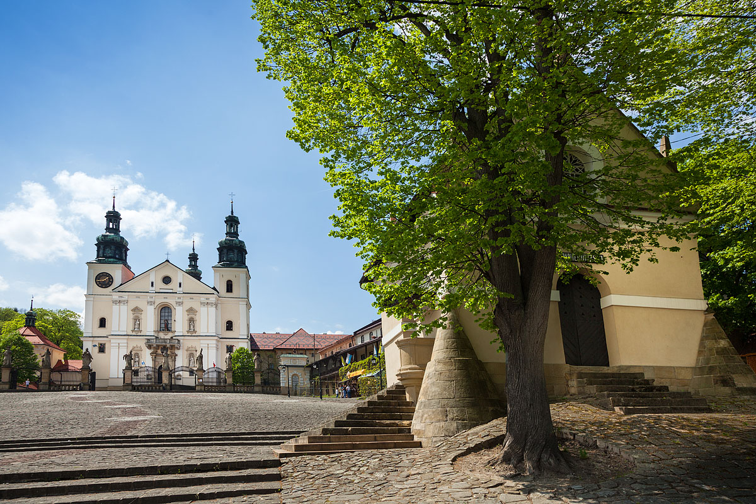

Urnes Stavkirke takes part in an international project implemented within the framework of: the “CULTURE” program of the European Economic Area Financial Mechanism 2014-2021 Measure 1: Improvement of cultural heritage management.

Sub-measure 1.1 Restoration and revitalisation of cultural heritage

**Name of the project: Heritage of the Sanctuary in Kalwaria Zebrzydowska on the UNESCO trail**

**Project Leader from Poland:** Klasztor OO. Bernardynów w Kalwarii Zebrzydowskiej

**Partner from the Donor-Country:** Urnes Stavkirke

The subject of the investment is the renovation of eight chapels located on the path trails of Kalwaria Zebrzydowska as well as the maintenance, renovation and changing function of three historic monastery buildings, which will be used for educational and cultural purposes.

**TASKS within the project:**

* Conservation work of eight chapels involving the restoration of elements of the wooden and stone decoration, historic paintings and statues and entrances to the chapels and the remaining decorations;
* Construction works adapting three buildings in Kalwaria Zebrzydowska in order to reuse them for educational, exhibition and training purposes together with the conservation of the historic structure of the buildings;
* Professional trainings for current and new employees as well as non-professional trainings for the local community and related institution and business entities. These trainings are necessary both to effectively manage the change in the organisation resulting from the new cultural-tourism infrastructure and to effectively implement the cultural-educational program.
* The cultural and educational offer includes numerous cultural events that address diverse audiences.
* Project management
* Project promotion – the objective of the promotion is to reach with information on the project and the new cultural and educational offer to the largest possible group of diverse audiences in all age groups, including the general public.
* Purchase of equipment required to conduct cultural activity and to protect the cultural heritage.

The scope of the project implemented with the participation of Urnes Stavkirke:

* Exchange of experiences and good practices;
* Training of tourist guides and cultural animators;
* Training and courses in the field of cultural heritage protection in particular with the adaptation of the cultural offer to the grade of the listed monument;
* Supporting the Leader in the implementation of the projects thanks to many years of experience in protecting the monument and making it accessible to the public;
* Active creation and implementation in the design process of cultural and educational offers;
* Creation of a joint project on the promotion of the UNESCO-listed heritage in both countries;
* Dissemination of projects results.

**desired EFFECTS OF THE PROJECT:**

* Enhancing public participation in culture;
* Strengthening the economic potential of the municipality and the region.
* Creation of a new diverse cultural and educational offer.
* After the completion of the project, further cooperation with the Project Partner in the implementation of the cultural-educational offer is assumed.

**Project Leader from Poland:** http://kalwaria.eu/aktualnosc/dziedzictwo-sanktuarium-w-kalwarii-zebrzydowskiej-na-szlaku-unesco

[www.eeagrants.org](http://pieskowaskala.eu/zamek/wielokulturowa-rzeczpospolita/www.eeagrants.org)

Support provided by the “CULTURE” Programme of the European Economic Area Financial Mechanism 2014-2021 and the state budget.